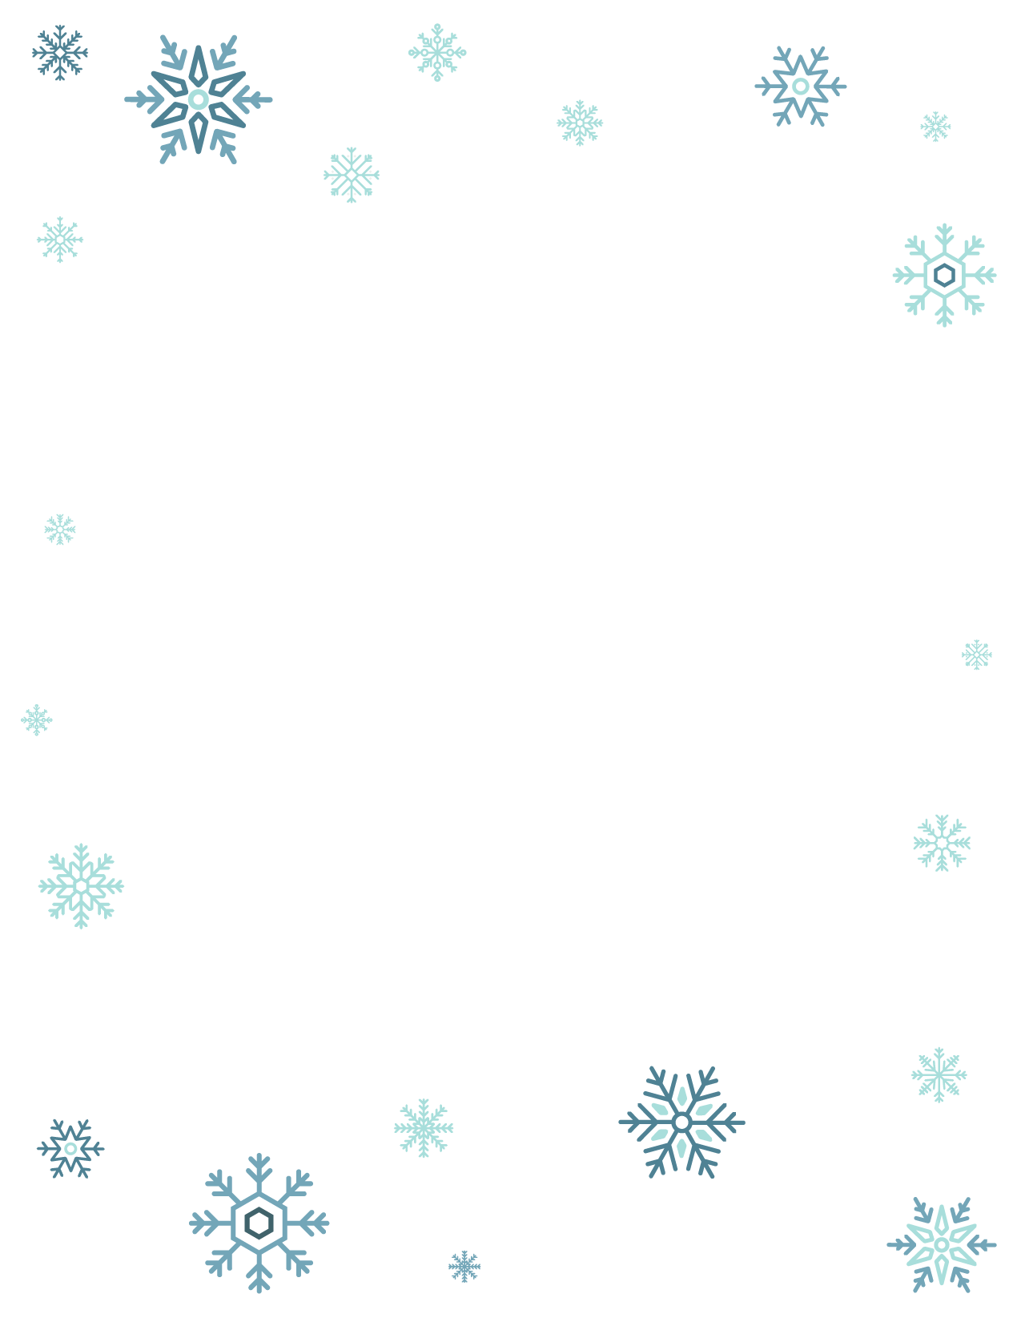Dear [Child’s name],

Ho Ho Ho and Merry Christmas! I got your letter all the

way here in the North Pole.

I can’t believe you are [child’s age] years old already! I am very proud of you for being very good and kind this year and for [adjust/add personal details]

The North Pole is very busy at this time of the year

getting everything ready. Rudolph and the other reindeer are excited for the big day!

Thank you for writing to me. Wishing you a very Merry

Christmas full of joy and magic!

* Santa Claus